Name __________________________________________ Life Science
Mr. P. Colombo

Date _____________________ Group _________ Lab Activity

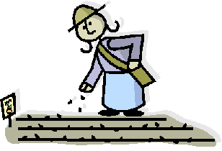
Classifying Seeds

Directions: The goal of this lab activity is to observe a sample of seeds and notice their features. Once you have done this you will separate the seeds into similar groups based on the features that you observed.

Record the features of each type of seed that you have observed in the table below. Once you have done this you should develop a key (on the back of this lab sheet) using the features of these different seeds.

Seed Type | Color | Length (mm) | Shape | Texture | Total Number/Sample

Be sure to answer the “Conclude and Apply” questions found on page 27 of your book!

